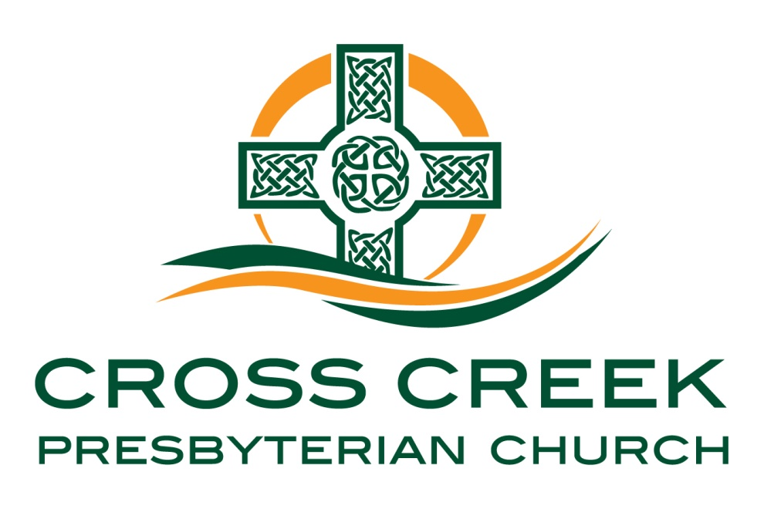

Oh come, let us worship and bow down;
let us kneel before the Lord our Maker!
For He is our God! - Psalm 95:6-7a

June 28, 2026

The Lord’s Day – June 28, 2026

Prelude
Welcome and Announcements
* Call to Worship Psalm 107:1-3
“Oh give thanks to the Lord, for he is good, for his steadfast love endures forever! Let the redeemed of the LORD say so, whom he has redeemed from trouble and gathered in from the lands, from the east and from the west, from the north and from the south.”
* Hymn of Adoration #101 Come, Thou Almighty King
* Opening Prayer
Call to Confession Isaiah 6:5
“And I said: “Woe is me! For I am lost; for I am a man of unclean lips, and I dwell in the midst of a people of unclean lips; for my eyes have seen the King, the LORD of hosts!”
Prayers of Confession
Assurance of Pardon Isaiah 6:6-7
“Then one of the seraphim flew to me, having in his hand a burning coal that he had taken with tongs from the altar. And he touched my mouth and said: “Behold, this has touched your lips; your guilt is taken away, and your sin atoned for.”
OT Scripture Reading: Isaiah 6:1-7 (Pew Bible pg. 571)
NT Scripture Reading: Ephesians 2:1-11 (Pew Bible pg. 976)
L: This is the Word of the Lord. C: Thanks be to God!
Giving of Tithes and Offerings 1 Chronicles 29:14

* Doxology (tune of “Old Hundredth” #731) “Doxology”

Praise God, from Whom all blessings flow; praise Him, all creatures here below;
Praise Him above, ye heavenly host; praise Father, Son, and Holy Ghost.

* Prayer of Thanksgiving

* Hymn of # Preparation #198 Lift Up Your Heads, Ye Mighty Gates!

* Sermon Text Psalm 24 (Pew Bible pg.458)
Sermon Title “Jesus, King of Glory” TE Ken Godwin

*Hymn of Reflection #243 Praise the Savior Now and Ever

Sacrament of the Lord’s Supper
(Please note: The purple cups in the outer ring contain wine, and the clear cups in the inner rings contain juice; bread is beneath each cup.)

Prayer for Transformation

Affirmation of Faith
Q. 45 What is the first commandment?
A. The first commandment is, Thou shalt have no other gods before me.
Q. 46 What is required in the first commandment?
A. The first commandment requireth us to know and acknowledge God to be the only true God, and our God; and to worship and glorify him accordingly.
Q. 47 What is forbidden in the first commandment?
A. The first commandment forbiddeth the denying, or not worshiping and glorifying, the true God as God, and our God; and the giving of that worship and glory to any other, which is due to him alone.
Q. 48 What are we specially taught by these words, before me, in the first commandment?
A. These words, before me, in the first commandment teach us, that God, who seeth all things, taketh notice of, and is much displeased with, the sin of having any other God.

Prayers of the People (followed by the Lord’s Prayer)

* Hymn of Faith #295 Crown Him with Many Crowns

* Benediction

*God Be with You Till We Meet Again #386 (Verse 1)
God be with you till we meet again; by his counsels guide, uphold you, with his sheep securely fold you: God be with you till we meet again. Till we meet, till we meet, till we meet at Jesus’ feet; till we meet, till we meet, God be with you till we meet again.

* Greeting of One Another

* Postlude

* Indicates please stand if able

Sermon Notes

Sermon Text: Psalm 24
Sermon Title: “Jesus, King of Glory” TE Ken Godwin

The answer to the question "who shall ascend" is the key to understanding Psalm Twenty-Four. The answer points us to the gospel and the King of Glory, Jesus Christ.

I. Gods sovereignly rules over his creation in holiness

II. God must be approached in purity

III. God’s Son is the ascended King through whom we must approach in purity

